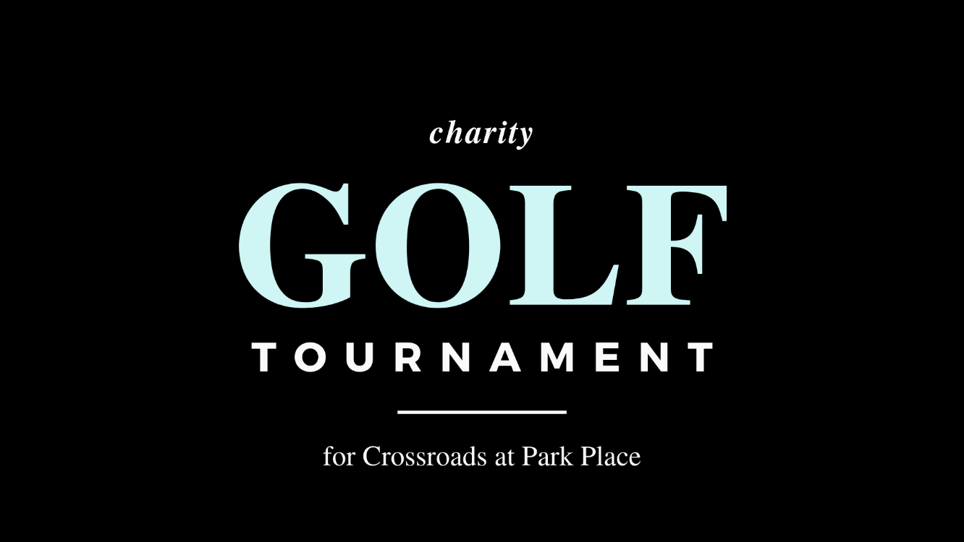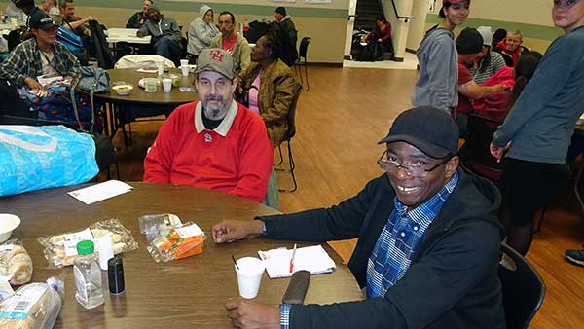

**SCHEDULE**

Monday, October 19, 2020

**Check-in**  7:00am

**Shotgun Start** 7:45 am

**Lunch & Awards** 12:00-1:30 pm

**Silent Auction** 12:00-1:30 pm

**TOURNAMENT INFORMATION**

**LOCATION**

Bay Oaks Country Club, 14545 Bay Oaks Blvd, Houston, TX 77059

**FORMAT**

Foursome Scramble

The grab and go breakfast includes pastries, fruit, juice, and coffee. The lunch buffet includes burgers, grilled chicken, beans, and potato salad.

**AWARDS AND PRIZES**

**1st Place Foursome**

$100/ea Bay Oaks Gift Certificate

**2nd Place Foursome**

$ 75/ea Bay Oaks Gift Certificate

**3rd Place Foursome**

$ 60/ea Bay Oaks Gift Certificate

**Closest to the Pin**

$ 25 Gift Card

**SILENT AUCTION**

There will be a silent auction after the round and ending after lunch.

Please note: Due to the pandemic, participants must abide by social distancing and any other requirements mandated by governmental entities and Bay Oaks Country Club as of the time of the event.

Since 2001, Crossroads at Park Place has been a Christian organization committed to promoting the health, hygiene and dignity of persons experiencing homelessness and poverty in Southeast Houston, Texas.

During the pandemic normal services have been cancelled. Crossroads provides a Houston Food Bank supported food distribution every Thursday. Fresh produce, rice, beans, and tortillas are passed out. We are serving roughly **450**

families per event.

**30,000**

People served per Thursday Food Distribution in 2020

**11,500**

Meals served in 2019

**3,500**

Hygiene packs provided in 2019

**1,200**

Loads of Laundry in 2019

**95**

Average Participants Tues & Thurs-2019

Monday, October 19, 2020

Bay Oaks Country Club

**For more information, contact**

Randy Hiriart, Event Organizer

[rhiriart@swbell.net](mailto:rhiriart@swbell.net)

**All proceeds from the Charity Golf Tournament go directly to Crossroads at Park Place.**

Gold Sponsor $1,450

Silver Sponsor $850

Team Sponsor $600

Hole Sponsor $250

Individual $150

Lunch Only $20

Donation ________

**TOTAL**

**SPONSORSHIP OPPORTUNITIES**

**Gold Sponsor** - $1,450

TWO Foursomes and a Hole Sponsorship sign.

**Silver Sponsor** - $850

Foursome and a Hole Sponsorship sign.

**Team Sponsor** - $600

Foursome

**Hole Sponsor** - $250

A sign with your company name placed at tee box

**Individual Player** - $150

Players paired with a random group making up a foursome

**Lunch Only** - $20

Please join us at Noon for Lunch and Silent Auction

**REGISTRATION**

Mail form and check to **Crossroads at Park Place**, 7843 Park Place Blvd, Houston, TX, 77087 Or, email to [rhiriart@swbell.net](mailto:rhiriart@swbell.net) or call 281-352-0770

**You may also register at the Crossroads website-www.crossroadsatparkplace.org**

**Crossroads** provides a welcoming, safe place for our poor and homeless neighbors to rest, relax, and experience the love of Christ through the helping hands of our volunteers.

While clients enjoy the respite and wellness this retreat from the streets provides, breakfast and lunch are served, along with generous portions of friendship.

Separate showering facilities are offered for women, men, and families. Volunteers launder and fold clothes while clients take part in meals, hairdressing services, needs assessments, social services referrals, health screenings, and other supportive interactions.

CROSSROADS is currently open each Thursday morning for food distribution to area families.

**crossroadsatparkplace.org**

**VISA**

**MASTERCARD**

**AMEX**

**DISCOVER**

**CC#**

**EXP. DATE**

**SIGNATURE**

**SECURITY CODE**

**PAYMENT**

**TEAM CAPTAIN**

**COMPANY**

**ADDRESS**

**CITY/STATE**

**EMAIL**

**PHONE**

**PLAYER #1**

**PLAYER #2**

**PLAYER #3**

**PLAYER #4**